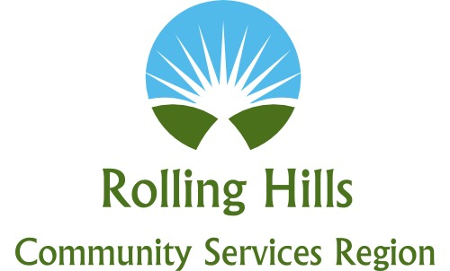
Buena Vista * Calhoun * Carroll * Cherokee * Crawford * Ida * Sac * Woodbury
Regional Adult Advisory Board Minutes
Meeting will be held via Zoom
May 24, 2021
1:00 p.m.

- Call to Order / Welcome and Introductions– Dawn Mentzer, CEO/Kim Keleher, Chair
Those in attendance: Dawn Mentzer, Theresa Jochum, Teresa Magnussen, Kim Keleher, Melissa Drey, Anita Schlender, Julie Albright, Kristin Nehring, Nicolle Eaton, Taya Vonnahme, Lisa Bringle, Kerri Hall, Todd Lange, LeAn Taylor, Leisa Mayer, Deb Burnett, Karla Manternach, Joleen Schmit, Jessi Maxwell, Mindi Rotert, Jim France, Dennis Bush

- Legislative Update –SF 619– Dawn Mentzer
Dawn Mentzer provided an overview of the legislation. This legislation will make sweeping changes to our mental health system in Iowa. The Governor has not signed it as of yet, but it did pass the House and Senate. This phases out the county property tax levy over two years as it changes to a state funded system. Next fiscal year, the county levies will be adjusted down to $21.14 which will reduce the overall tax asking to $4.5 million in county funds and $3.3 million from the state. Our budget is set for next year atover $8 million so reserves will be used. Our fund balance needs to be below 40% and 20% in FY23 and 5% thereafter, or any funds over will revert back to the state. The legislation does not define non-core services which includes our transition services at Stepping Stones. Dawn has made the State aware of our non-core services that we need.

Kim Keleher commented that this has happened very quickly, and ask if providers should be concerned that payments (block grants from the region) may not be on time? Dawn does not believe there will be any delays as we have a fund balance.
Dawn Mentzer talked about the performance based contracts that will need to be in place. If outcomes are not met (by providers and programs) our payments from the State can be reduced.
3. Future of Core Services Development
- Access Center/Subacute Discussion – Dawn Mentzer, Nicolle Eaton, Melissa Drey
Nicky Eaton reported that until the real estate issue (current Assessment Center building) is still unresolved. They have met with substance abuse providers, and it was positive that they are willing to collaborate on providing substance abuse service. A lot of the substance abuse providers are already collaborating together, and several are IPN providers (which allows them to get or use funds for those without insurance or funding).

Dawn Mentzer said that the real estate purchase of the current assessment center is on the agenda for Wednesday’s Governance Board meeting. Based on the current legislation she would like to see the property owned by a county or provider rather than the region (if the region would be dissolved).

Theresa Jochum reported that a new jail is being built, and it has been brought up to place a separate building that would be 24 beds and staffed by Siouxland Mental Health, the question would be who would own it or pay for it. It would be for inmates and the whole region. Nicky would like more information.

Dawn Mentzer asked for a consensus from the group for a recommendation to take to the Governance Board on Wednesday. Kim Keleher recommends Siouxland Mental Health buy the building (with Regional funding) and the region increase funding for remodeling.
Nicky Eaton agrees with Kim, that this would be a good proposition.
Karla Manternach also agrees that region does not purchase property and for Siouxland Mental Health to purchase it.
Kristin Nehring agrees with Siouxland Mental Health Center owning a building.

- Community Based Crisis
Regional staff met and it was decided to invite law enforcement from all 10 counties on June 8, 1pm at Cobblestone in Holstein. Melissa has talked with the majority of Sheriff and police departments. A reminder/invitation will be mailed out next week.

- IRSH update
Dawn Menter updated: a pilot project with Trivium (formerly Crossroads) based on the presentation they gave last month will start with our Region and Southwest Iowa Region. Dawn feels confident with the program and the approach Trivium is taking. The pilot will be in Sioux City. Todd Lange was involved in the meetings, and a team at Amerigroup looking at development of rates and so forth.

- Humboldt/Pocahontas update
A Coordinator is being hired. Ongoing meetings are being held with both counties for a smooth transition.

- Provider Updates:
Kim Keleher, Plains Area Mental Health Center: ACT personnel is being hired, once the nurse is on board, they will start taking referrals. The program is being initiated in Crawford and Carroll Counties currently.

- Next Meeting: June 28, 2021 at 1 pm via Zoom

